War Robot

Duman Bayron¹, Moldabaev Ravil², Amirkhanov Temirlan³
¹School of IT and Engineering, Kazakh-British Technical University, Almaty, Kazakhstan
¹b_duman@kbtu.kz; ²r_moldabayev@kbtu.kz; ³t_amirkhanov@kbtu.kz

Abstract— The project develops and executes a War Robot system through a UGV platform that uses ROS2 on a Raspberry Pi for platform control. The main project goal establishes the development of a self-operating robot which detects red-coloured targets including balls or balloons followed by appropriate shooting procedures. The robot combines several components including a camera module used in real-time image processing together with colour detection algorithms for target recognition with a motorized turret mechanism for aiming and firing. The system contains a joystick interface as manual control with ROS2 managing sensor fusion operations along with node communication and mobility control capabilities. The robot achieved its designed function by detecting red targets along with demonstrating effective firing response capabilities. The intended purpose of this system exists for competition-based experimental robotics applications alongside training simulations.

Keywords—“UGV, Raspberry PI, object detection, War robot, Target tracking, Autonomous shooting”

- Introduction
The design follows the creation of a War Robot system that uses a UGV platform controlled by ROS2 on a Raspberry Pi platform. The robotic system seeks to develop self-operating capabilities that identify red targets and activate the mechanical firing system. The system combines a camera subsystem for image processing with color detection algorithms that recognize targets and ROS2 handles all communication tasks and movement control and sensor fusion responsibilities. The system includes an optional joystick function to provide manual control through ROS2 on the Raspberry Pi. The main uniqueness of this project lies in its real-time functionality to detect targets and automatically fire while operating from a flexible platform at a realistic cost. The integration of detection with control features separates this robot from other systems since it provides valuable capabilities for robotic competitions and experimental research and training environments.

- Methodology
This section describes the methodology used in the development of the War Robot system. The project involves both hardware and software integration using a ROS2-based control framework on a Raspberry Pi 4.
  - Hardware architecture of this project
The robot is built on a UGV (Unmanned Ground Vehicle) platform equipped with various components. The core hardware includes: (Table 1: Mechanical components with specifications)
TABLE I
Mechanical components with specifications
 | Hardware architecture of the project
 | Component | Specs | Remarks
1 | Raspberry Pi 4 | Quad-core, 1.5 GHz, 4GB RAM, runs Ubuntu with ROS2 | 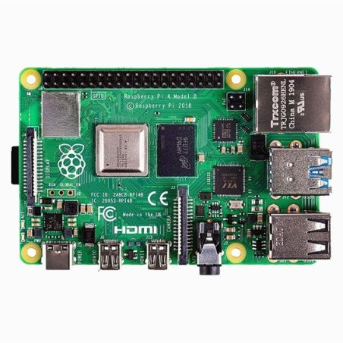
2 | Motor Driver (L298N) | Dual H-Bridge, 2A per channel, 5–35V input | 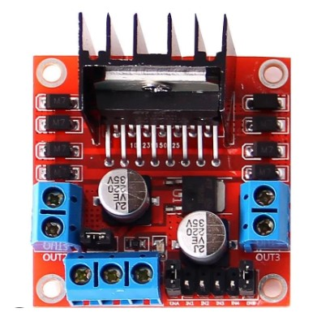
3 | USB Camera Module | 640×480 resolution, USB 2.0 interface
  For red object detection
4 | Servo Motor | Operating voltage: 4.8–6V, rotation range: 180° | Turret aiming system
5 | Joystick Module | Dual-axis analog stick, 5V logic level | 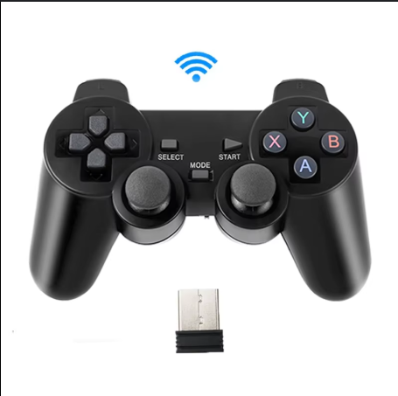
5 | Orbeez Gun | Electric firing, range approx. 2.5–3 m, 6–9V input | 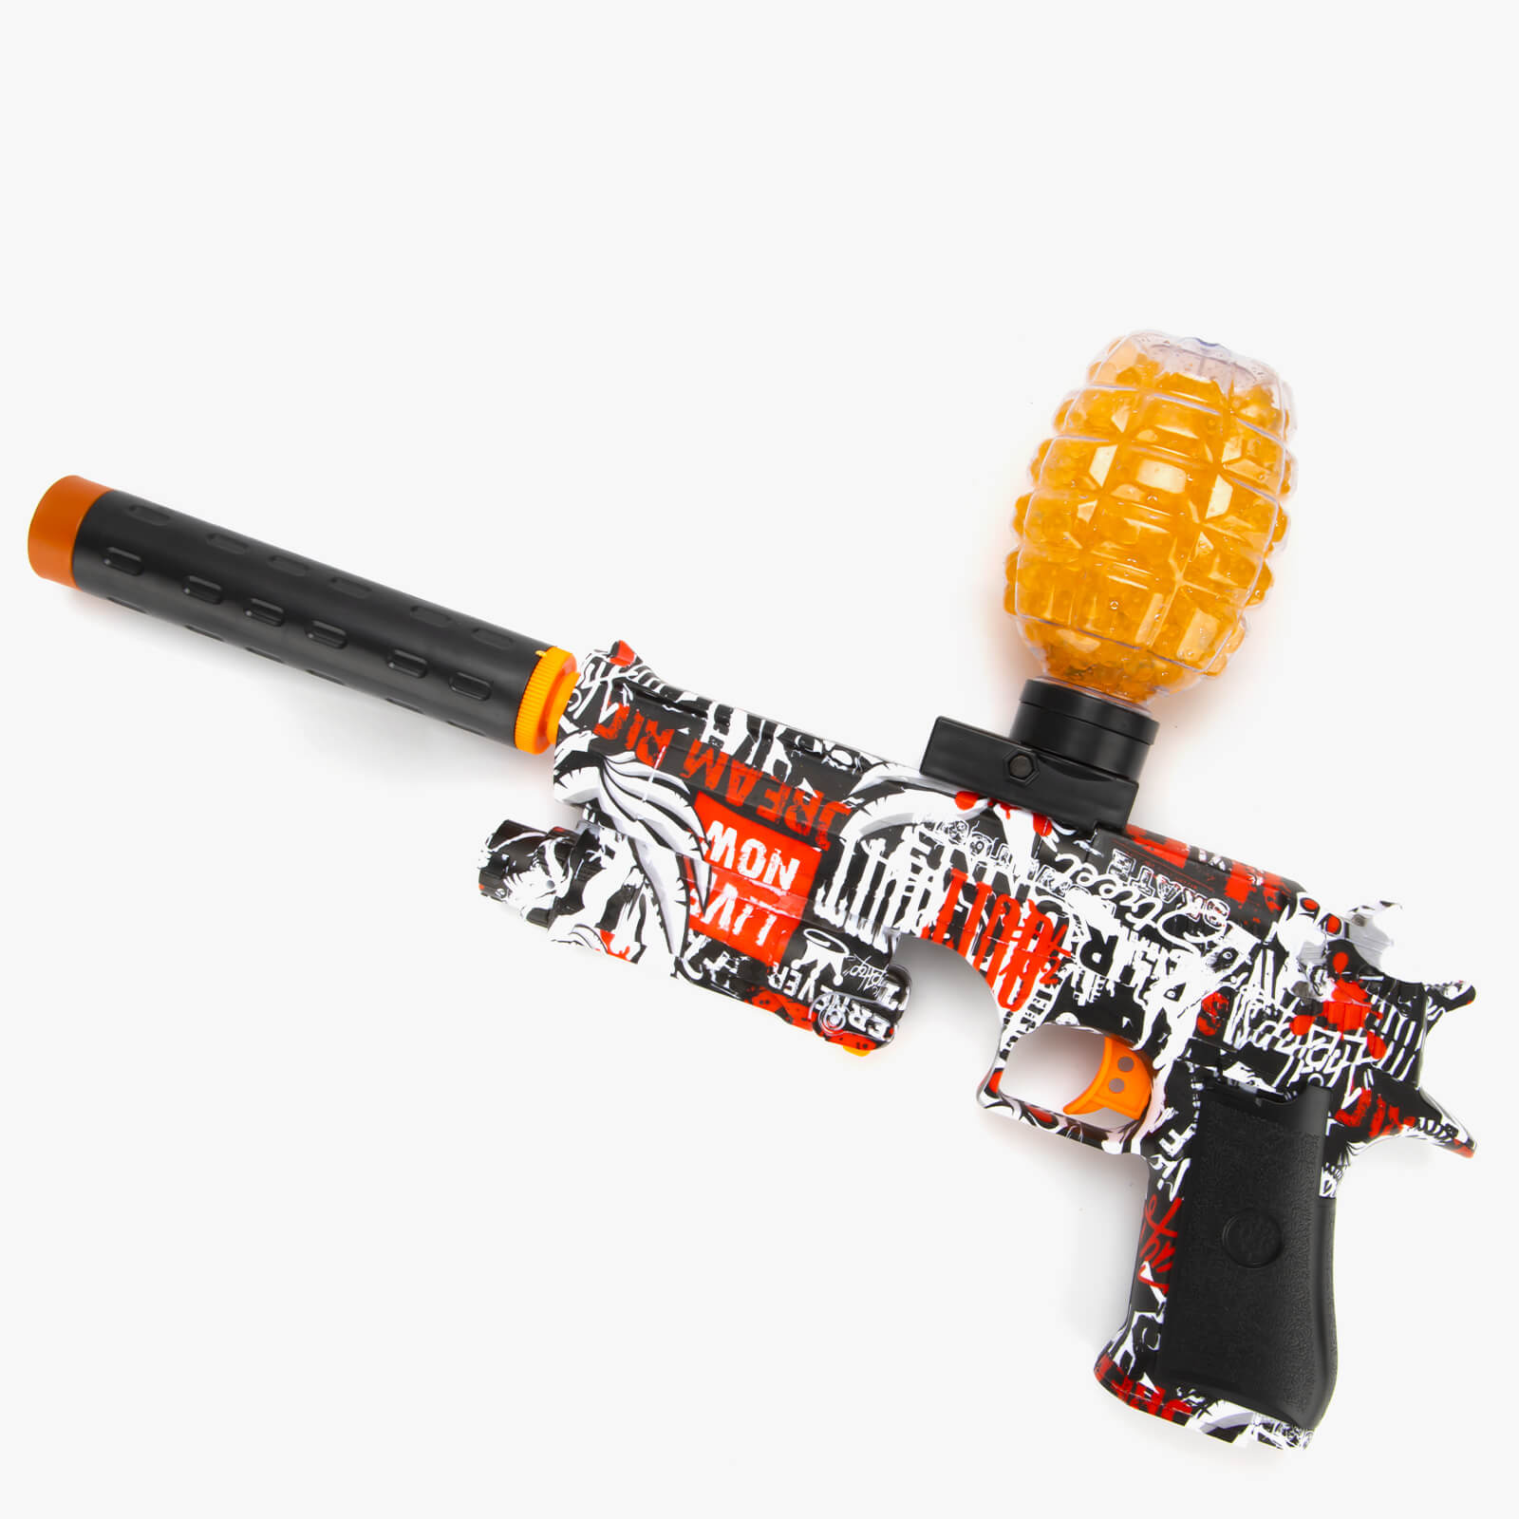

The War Robot system is powered by a 12V battery, which serves as the primary energy source. A DC-DC step-down converter reduces this voltage to 5V, making it suitable for powering low-voltage components such as the microcontrollers and the Raspberry Pi 5. The microcontrollers are responsible for controlling two servo motors (Servomotor 1 and Servomotor 2). (Figure 1 – Connection between hardware components)

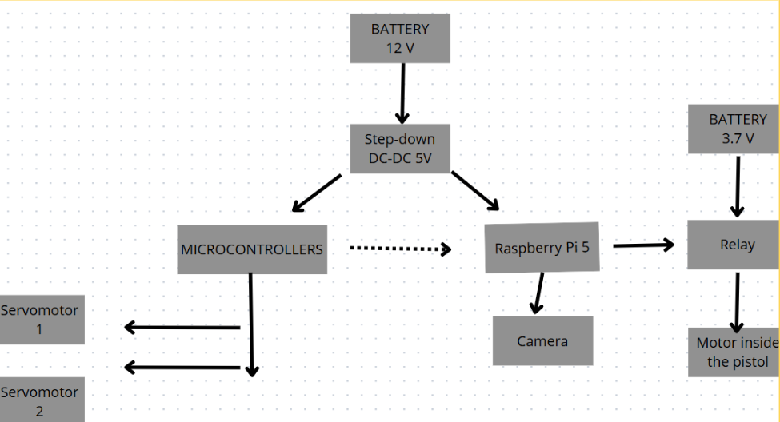
Figure 1 – Connection between Hardware components

These servos are likely used for turret positioning, enabling horizontal and vertical aiming. Simultaneously, the Raspberry Pi 5, also powered through the 5V output, serves as the core computing unit. It runs ROS2, processes the video feed from the USB camera, and handles object detection using computer vision. When a red target is detected, the Raspberry Pi sends a control signal to a relay module, which is connected to a 3.7V battery. This battery powers the motor inside the Orbeez gun (pistol), allowing it to shoot at the target. The relay(motor driver) acts as a switch, isolating the high-current load of the firing motor from the Raspberry Pi while enabling software-based activation. The dotted line between the Raspberry Pi and microcontrollers represents a communication link (e.g., UART, I2C, or GPIO), used for coordination between image processing logic and servo control.

- Software architecture
The software architecture of the UGV (Unmanned Ground Vehicle) robot is designed to provide autonomous behavior using ROS 2 (Robot Operating System 2) and Python. The software is modular, allowing for ease of maintenance, scalability, and future upgrades. The core functionalities are divided into three main modules: the Camera Launch Module, the Color Tracking Module, and the Shooting Module. Each module is responsible for a specific aspect of the robot's operation, working together in real-time to achieve the mission of detecting, tracking, and responding to red targets in the environment. (Figure 2 – Software interconnection). The UGV software system incorporates ROS 2 and Python to operate through three essential modules which guide perception and decision-making and control actions.
From all software modules the camera launch module (camera_launch.py) possesses responsibility to activate the robot's vision system. The software launches the usb_cam node to get real-time video from a USB camera installed on the robot while also executing the image_proc::RectifyNode to correct lens distortion for geometric accuracy in images. The launch arguments include namespace for modular deployment while container enhances performance by organizing nodes in groups. The output consists of two topics /image_raw which broadcasts image frames and /camera_info which delivers the camera calibration parameters. The system relies on this module to generate reliable image data which becomes accessible for all components.

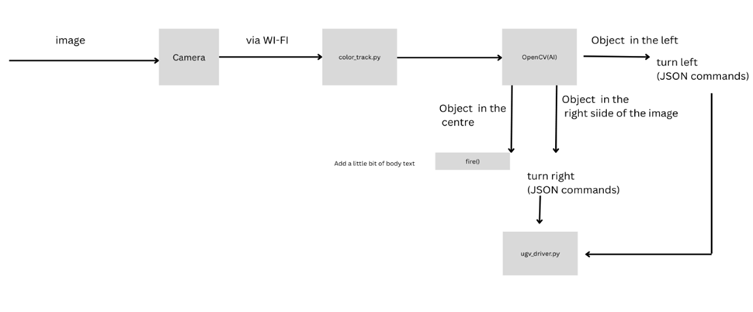
Figure 2 – Software interconnection

Color tracking module (color_track.py) functions as the robot’s perception system while executing decision-making tasks. The module obtains camera frames from the /image_raw subscription to perform real-time operations using OpenCV before detecting outlines to locate and measure the biggest red object through centroid location. The robot determines its movement through position and size analysis of the target object by rotating for offset locations while keeping a forward pace from distant targets and reversing course for close targets and finally halting with gun readiness when the object occupies the middle position. The codes transmit action requests to ugv_interface/Behavior action server through JSON format. The module produces diagnostic output for debugging purposes through publication to /color_track/result which displays annotated image frames with bounding boxes and position indicators.
The last module consists of two parts within shooting.py that performs physical interactions through the environment (shooting mechanism along with GPIO pin control). Throughout the GPIO Pin 18 interface the Raspberry Pi controls the connected relay through electrical signals for mechanical function activation. By calling the fire() function four gunshots will be triggered through alternating the GPIO pin while each successive blast waits five seconds. The physical shooting capability of the robot depends on this module to trigger responses to detected targets.
The ROS 2 topics and actions serve as the medium for establishing mutual communication links between the three modules. Swarm Robotics depends on the tracking module to accept camera inputs which then leads to actions completed by the shooter function. Future development for the robot will gain increased functionality because the defined structure provides dependable operation alongside easy testing capabilities.

Pseudocode

Input:
- BIM_checklist = list of BIM objects with coordinates (x, y) and surface angles α
- Tᵣ = distance threshold
- Angle difference threshold (for surface continuity check)
Output:
- Flag₁: Triggers the vision detection system
- Flag₂: Indicates whether to continue with next object pairs

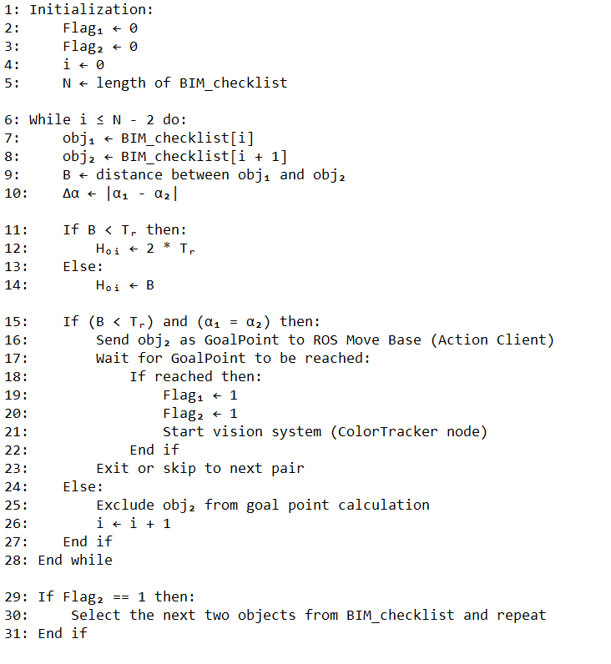

This pseudocode describes a robot control system that uses Building Information Modeling (BIM) data for object detection and navigation. It iterates through a list of detected objects, calculating distances and angles between them. If a reference object and a target object are within defined distance and angle thresholds, a navigation goal is sent to the robot. Upon reaching the goal, the robot activates local visual tracking (e.g., camera-based) to detect and respond to specific features. If the conditions are not satisfied, the robot skips the object and continues the process. This system integrates BIM-based navigation with local perception for efficient and context-aware movement.

Detailed code in Github: https://github.com/Ravil180904/Mobile-robot-report/tree/main/github%20codes

- Experimental results
- Experimental setup
The project developed a robotic system based on games through ROS 2 implementation on UGV Rover PI platform which used Raspberry Pi 4 as its primary processing component. The mobile robot operated automatically to identify red targets as it engaged in active tasks while simulating two robots competing to hit each other. An autonomous UGV system required integration of visual processing and mechanical operation with motion guidance for achieving functionality.
A USB camera mounted on the robot operated through the perception system to provide uninterrupted visual data transmission during forward observation. Robotic images moved to ROS 2 topics and then entered the vision pipeline structure based on OpenCV in the color_track.py codebase. The color detection system operated by converting RGB image streams into HSV (Hue Saturation Value) color space because this color space maintains stability when detecting colors under different environmental lighting conditions. Inside the script the red color detection boundaries were specifically adjusted through threshold parameters set as lower_color = [0, 115, 0] and upper_color = [5, 255, 255]. The selected color range resulted from empirical testing to separate red balloons connected to the opponent robot.
When the camera detected a red object the system commenced an ordered workflow that included the detection of contours and the computation of centroids and tracking of positions. The robot used object positions in the image frame to determine moving forward or rotating back or stopping before starting the firing process. The execution flow of commands proceeded through the ugv_interface/Behavior action server by accepting JSON-based requests coming from the color_track node. The usage of ROS 2 topics and actions created a unified communication pathway among the perception, control and actuation layers.

- Experimental results and discussion
Tests took place indoors between two robot devices which carried three red balloons each. The main success factor consisted of detecting all balloons on opposing robots prior to the opponent robot while maintaining quicker shooting times. The testing identified that the red balloon detection algorithm demonstrated successful performance in identifying balloons with 90% accuracy while the camera detected them in consistent lighting and under proper viewing conditions. The ROS image messages translated into OpenCV format by the OpenCV-based color tracking node enabled the application of HSV color filters and the issuance of turn left, turn right or fire JSON commands to the behavior_server node for action execution.

When the target stood upright within the camera's area the relay module controlled shooting mechanism resulted in accurate orbeez gun firing. Observers needed about 3 seconds to locate and trigger a shot at a single balloon but the operating conditions like robot mobility and distance affected this timing. The detection system lost its accuracy to below 70 percent under dim or irregular environments which led to targeting errors or false identifications of objects apart from red ones. The response time of servomotors caused short delays when aligning gun systems which reduced the engagement speed. The results indicate effective performance of this system under defined situations yet improved motor response time combined with better lighting would produce better results in real-world conditions.

Lightning condition | Detection Accuracy (%) | Number of Trials
Bright, Consistent | 90 | 20
Dim, Consistent | 85 | 15
Uneven, Variable | 70 | 10
Table 2. Detection Accuracy Under Different Lighting Conditions
This table presents the effectiveness of the color detection system in recognizing red balloons across a variety of lighting environments, including optimal illumination, reduced light levels with uniformity, and inconsistent lighting with fluctuations. It provides a comparative overview by detailing the success rate of detection under each condition, supported by the number of experimental trials conducted. The data underscores the system's robustness in controlled settings and its challenges when faced with unpredictable lighting variations, offering valuable insights into the environmental adaptability of the computer vision component.

Action | Average Time (seconds) | Number of Trials
Ballon Detection | 2.5 | 25
Target alignment | 0.8 | 25
Shooting Activation | 0.2 | 25
Total Engagement Time | 3.5 | 25
Table 3. Average Response Times
This table captures how quickly our robot can spot, aim, and shoot at the red balloons, breaking down the whole process into easy-to-understand steps. It shows the time it takes for the robot to first notice a balloon, then adjust its orbeez gun to line up the shot, fire the gun, and finally complete the entire sequence from start to finish. Each step’s duration is averaged out from several test runs, giving a clear sense of how fast the robot reacts at each stage. It’s like timing how long it takes to spot a friend in a crowd, turn to face them, wave, and finish the whole interaction—revealing where the robot shines and where it might need a little nudge to speed things up.

Distance (meters) | Success Rate (%) | Number of Attempts
0.5 | 95 | 20
1.0 | 85 | 20
1.5 | 70 | 20
Table 4. Shooting Success Rate by Distance
This table reflects how well the robot’s orbeez gun hits its target at various distances, offering a glimpse into the shooting mechanism’s reliability across different ranges. It lists the distances tested, the percentage of successful shots, and the number of attempts made at each range. The results show how the robot performs up close versus farther away, shedding light on the practical limits of the gun’s accuracy and the potential need for adjustments in targeting or hardware as the distance increases—much like figuring out how far you can reliably toss a ball to hit a target.
- Conclusions
The project proved how computer vision technology can work with robotic action commands through the combination of Raspberry Pi 4 and ROS 2 on UGV Rover PI. The robot system used OpenCV to detect red balloons then automatically fired the orbeez gun to hit the target as required in the "Robot vs. Robot" game scenario. The system offers module-based structure while using ROS 2 for node communication and enables economic operation through the utilization of the inexpensive Raspberry Pi for processing and control needs. The system suffers from two main performance constraints which include its illumination dependency and motor slowness. Project improvements for the future will require the implementation of automation methods for light adjustment detection as well as modifications to servomotor speed and machine learning applications for tracking targets with intelligence

Acknowledgement
We acknowledge the guidance and mentorship of course and robotics lab instructors to complete this project.

References
- Suraksha Bhat, Preeti Kini, Anjana Nair, Neha Athavale, Color Tracking Robot, International Journal of Recent Research in Mathematics Computer Science and Information Technology, Vol. 3, Issue 1, pp: (18-22), 2016
- Genci Capi, Hideki Toda, Takuya Nagasaki, A vision based robot navigation and human tracking for social robotic, IEEE journal paper, 2010
- Aji Joy, Ajith P. Somaraj, Amal Joe, Muhammed Shafi, Nidheesh T M., Ball tracking robot using image processing and range detection, International Journal of Innovation Research in Computer and Communication Engineering, 2014
- Color tracking with movement [Online] Available: https://www.ez-robot.com/learn-robotics-color-tracking-through-movement.html?srsltid=AfmBOorXqH_J_T3_XbsI8HTym1nINxlegMX5J2WhROM4rJlMXh2jfiFL

